SQL Server for Healthcare
Schema Design, Temporal Auditing & Clinical Analytics
DAY 2

Day 2 assumes SQL fundamentals (SELECT, JOIN, basic normalization). We do not reteach them. The focus is healthcare database engineering: modeling real clinical and billing data, auditing it for HIPAA, querying it for clinical analytics, and making it fast at hospital scale.
Everything runs in SQL Server (SSMS or Azure Data Studio). One database, CareBridgeDB, is built up across all five modules - each lab adds to the same schema, ending in the Final Assignment.

The recurring cast (use these names in every scenario)
Persona | Role / what they care about
Dr. Maya Patel | Chief Medical Officer - clinical quality, readmissions, patient safety.
Priya Nair | Data Architect - schema, integrity, performance, audit design.
Ethan Brooks | Compliance Officer - HIPAA, audit trails, who-changed-what.
James Rodriguez | Revenue Cycle Manager - claims, reimbursement, revenue leakage.

The five modules
# | Module | Core skill
1 | Healthcare Data Modeling | Schema, PK/FK, constraints
2 | Temporal Tables & HIPAA Auditing | System-versioned history
3 | Advanced Queries for Clinical Analytics | CTEs, window functions
4 | Indexing for Healthcare Scale | Clustered/NC/covering indexes
5 | Stored Procedures & HIPAA Views | Encapsulation + de-identified access

SETUP (5 minutes, do once at the start)
Each student runs this to create the database everything else uses:
CREATE DATABASE CareBridgeDB;
USE CareBridgeDB;

Module 1 - Healthcare Data Modeling
Goal: model the core clinical and billing entities of a hospital and the relationships between them, with real constraints.
Theory
Three relationships are the backbone of every hospital database:
- A Patient has many Encounters (each visit/admission is one encounter).
- An Encounter has many Diagnoses and many Procedures.
- Billing hangs off encounters: an Encounter generates Claims against a patient's Insurance.

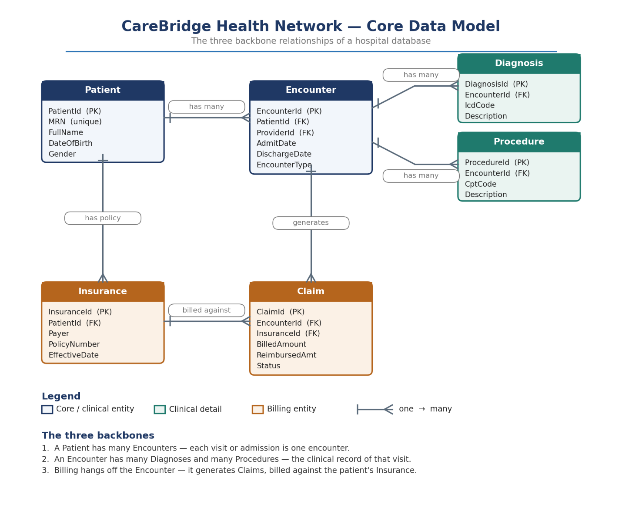
1. Patient = Customer
A Patient is just a person who comes to the hospital. Example: Arjun Mehta comes to the hospital
2. Encounter = One Visit to the Hospital
Each time the patient visits or gets admitted, that is one Encounter.
Example:
- Visit 1: Fever check (Outpatient)
- Visit 2: Emergency admission
- Visit 3: Surgery admission
So one patient can have many encounters (many visits)
3. Diagnoses = “What problem was found during the visit”
During each visit, doctors may find one or more health issues.
Example during one encounter:
- Flu
- High BP
One visit can have many diagnoses
4. Procedures = “What treatment was done”
Doctors may perform one or more treatments/tests during a visit.
Example:
- Blood test
- X-ray
- Surgery
One visit can have many procedures
5. Claims = “Bill sent to insurance”
After the visit, hospital creates a bill and sends it to insurance.
Example:
- Total cost = ₹50,000
- Insurance pays ₹40,000
- Patient pays remaining ₹10,000
Each encounter generates a claim
6. Insurance = “Who pays the bill”
Insurance is the company that helps pay hospital costs.
Example:
- Star Health
- HDFC Ergo

Clinical vs billing is the key modeling decision: clinical data (diagnoses, procedures) describes care; billing data (claims, reimbursement) describes money.
It means you should separate what happened medically from what it costs.
- Clinical data (care side):
Describes what doctors did and found
→ diagnoses, symptoms, procedures, treatment
- Billing data (money side):
Describes how the hospital gets paid
→ bills, insurance claims, payments, reimbursements
They link through the encounter but are governed and accessed differently - which matters for the HIPAA views in Module 5.
Scenario
Priya Nair is designing CareBridge’s core database schema. She must get the eight foundational tables right from the start, since every future module depends on this structure.
Hands-On Lab - Build the core schema
Run these in order. Reference tables (no dependencies) first, then the tables that reference them.
-- Department table
-- Key healthcare decision data:
-- DepartmentName (service line reporting), Location (capacity planning, hospital ops)
-- Why datatype matters:
-- NVARCHAR supports multi-language hospital systems and future expansion
-- Small structured text avoids fragmentation in reporting systems

CREATE TABLE Department (
DepartmentId INT IDENTITY(1,1) PRIMARY KEY,
Name NVARCHAR(100) NOT NULL,
Location NVARCHAR(100) NULL
);

-- Provider table
-- Key healthcare decision data:
-- Specialty (clinical workload distribution Cardiology, Neurology, Orthopedics, Emergency Medicine), -- DepartmentId (resource allocation)
-- Why datatype matters:
-- NVARCHAR ensures accurate storage of medical specialties (standardized but extensible)
-- Foreign key ensures care accountability and audit traceability (HIPAA compliance)

CREATE TABLE Provider (
ProviderId INT IDENTITY(1,1) PRIMARY KEY,
FullName NVARCHAR(150) NOT NULL,
Specialty NVARCHAR(100) NOT NULL,
DepartmentId INT NOT NULL
REFERENCES Department(DepartmentId)
);

-- Patient table (PHI / HIPAA sensitive)
-- Key healthcare decision data:
-- MRN (unique identity across hospital network), DateOfBirth (risk scoring), Gender (clinical analytics)
-- Used to calculate age, which helps estimate health risk.
-- Older patients → higher risk for chronic diseases
-- Infants/children → different risk profiles
-- Age is used in:
-- ICU risk prediction
-- Readmission risk
-- Insurance risk scoring

-- Gender (clinical analytics)
-- Used to identify disease patterns across populations.
-- Some conditions are more common in males or females.
-- Helps in:
-- Clinical research and studies
-- Treatment effectiveness analysis

-- Why datatype matters:
-- NVARCHAR protects PHI integrity (no truncation of names), DATE ensures accurate age calculation
-- BIT for IsActive supports fast filtering for live patient population
-- MRN is UNIQUE for patient identity safety across encounters

CREATE TABLE Patient (
PatientId INT IDENTITY(1,1) PRIMARY KEY,
MRN NVARCHAR(20) NOT NULL UNIQUE,
FullName NVARCHAR(150) NOT NULL,
DateOfBirth DATE NOT NULL,
Gender CHAR(1) NOT NULL
CHECK (Gender IN ('M','F','O')),
City NVARCHAR(100) NULL,
IsActive BIT NOT NULL DEFAULT 1
);

-- Insurance table
-- Key healthcare decision data:
-- Payer (revenue source tracking), PolicyNumber (claim validation), EffectiveDate (coverage validity)
-- Why datatype matters:
-- DATE ensures accurate coverage windows (critical for claim approval)
-- NVARCHAR supports multiple insurance providers and formats
-- Foreign key ensures billing integrity per patient

CREATE TABLE Insurance (
InsuranceId INT IDENTITY(1,1) PRIMARY KEY,
PatientId INT NOT NULL REFERENCES Patient(PatientId),
Payer NVARCHAR(120) NOT NULL,
PolicyNumber NVARCHAR(50) NOT NULL,
EffectiveDate DATE NOT NULL,
ExpiryDate DATE NULL
);

-- Encounter table (core clinical event log)
-- Key healthcare decision data:
-- AdmitDate/DischargeDate (Length of Stay, operational load), EncounterType (care classification)
-- Patient recovery tracking
-- Efficiency of treatment
-- Hospital performance comparison

-- ProviderId/DepartmentId (performance analytics, staffing optimization)
-- Why datatype matters:
-- DATETIME2 provides precise clinical timeline tracking (audit-grade accuracy for HIPAA)
-- CHECK constraint ensures valid clinical states (Inpatient/Outpatient/ED)

CREATE TABLE Encounter (
EncounterId INT IDENTITY(1,1) PRIMARY KEY,
PatientId INT NOT NULL REFERENCES Patient(PatientId),
ProviderId INT NOT NULL REFERENCES Provider(ProviderId),
DepartmentId INT NOT NULL REFERENCES Department(DepartmentId),
AdmitDate DATETIME2 NOT NULL,
DischargeDate DATETIME2 NULL,
EncounterType NVARCHAR(30) NOT NULL
CHECK (EncounterType IN ('Inpatient','Outpatient','ED'))
);

-- Diagnosis table (clinical reasoning layer)
-- Key healthcare decision data:
-- ICD Code (standardized disease classification), DiagnosedOn (clinical timeline)
-- Why datatype matters:
-- NVARCHAR ensures compatibility with ICD standards and international coding systems
-- DATETIME2 supports audit trails for medical decision history

CREATE TABLE Diagnosis (
DiagnosisId INT IDENTITY(1,1) PRIMARY KEY,
EncounterId INT NOT NULL REFERENCES Encounter(EncounterId),
IcdCode NVARCHAR(10) NOT NULL,
Description NVARCHAR(200) NOT NULL,
DiagnosedOn DATETIME2 NOT NULL DEFAULT SYSUTCDATETIME()
);

-- Procedure table (treatment execution layer)
-- Key healthcare decision data:
-- CPT Code (procedure standard), PerformedOn (clinical execution timestamp)
-- Why datatype matters:
-- DATETIME2 ensures precise OR/clinical timing accuracy for compliance and billing reconciliation

CREATE TABLE [Procedure] (
ProcedureId INT IDENTITY(1,1) PRIMARY KEY,
EncounterId INT NOT NULL REFERENCES Encounter(EncounterId),
CptCode NVARCHAR(10) NOT NULL,
Description NVARCHAR(200) NOT NULL,
PerformedOn DATETIME2 NOT NULL
);

-- Claim table (financial layer of healthcare system)
-- Key healthcare decision data:
-- BilledAmount (revenue), ReimbursedAmt (insurance payment tracking), Status (cashflow pipeline)
-- Why datatype matters:
-- DECIMAL(12,2) ensures financial precision (no rounding errors in billing systems)
-- NVARCHAR supports insurance workflow states (Submitted/Paid/Denied)
-- This table directly impacts hospital revenue leakage analysis and audit reporting

CREATE TABLE Claim (
ClaimId INT IDENTITY(1,1) PRIMARY KEY,
EncounterId INT NOT NULL REFERENCES Encounter(EncounterId),
InsuranceId INT NOT NULL REFERENCES Insurance(InsuranceId),
BilledAmount DECIMAL(12,2) NOT NULL,
ReimbursedAmt DECIMAL(12,2) NULL,
Status NVARCHAR(20) NOT NULL
CHECK (Status IN ('Submitted','Paid','Denied'))
);

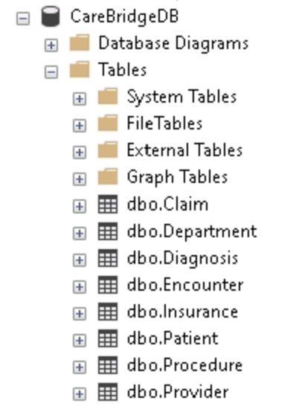

Seed a little sample data
1,000 patients, 30 providers, 10 departments, 1,184 insurance rows
2,246 encounters, 3,085 diagnoses, 3,470 procedures, 2,246 claims
107 thirty-day readmissions (readmission analytics will light up)
77 high-risk patients (3+ inpatient admissions)
434 denied + 606 pending claims → a clear, large revenue-leak story
104 deceased/inactive patients (fatal severe/critical inpatient cases)
Avg inpatient LOS ~9.7 days

Run the “CareBridgeDB SeedData.sql”
Expected Output
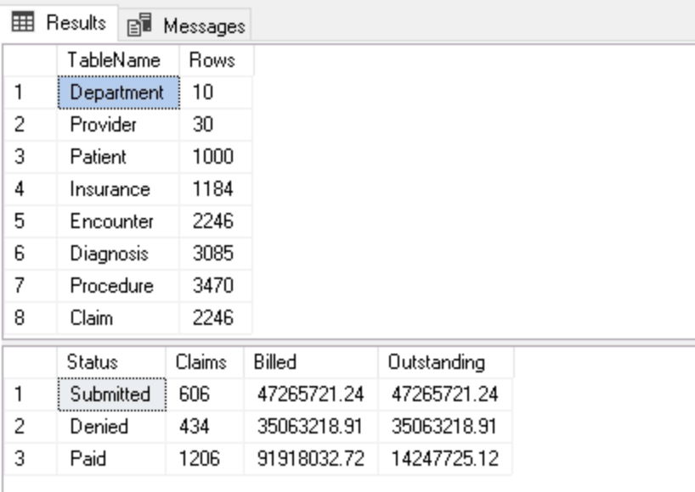
Mini Case Study
MINI CASE STUDY - "Flu Surge Weekend"
MINI CASE STUDY - "The Flu Surge Weekend"
The Situation
It is Friday evening at CareBridge Hospital.
A severe influenza outbreak begins spreading across the city. By Saturday morning, the Emergency Department (ED) is overwhelmed. Normally the hospital sees around 80 ED visits per day.
This weekend, patient arrivals spike to over 300%.
The waiting room fills up. Nurses need to register patients immediately, but many physicians are still busy treating existing cases.
At the same time, the Chief Medical Officer, Dr. Patel, requests hourly reports showing:
- Which departments are handling the most flu patients
- How quickly patients are being admitted
- Whether additional staffing is needed

The database must support both operational speed and executive reporting.
Business Challenge
The original database design required every Encounter to have an assigned Provider.
In your ERD, the Encounter table contains:
Encounter
----------
EncounterId (PK)
PatientId (FK)
ProviderId (FK)
AdmitDate
DischargeDate
EncounterType

Every Encounter must have an assigned Provider.

During the surge this created a bottleneck:
Registration staff could not create an encounter until a physician was assigned.
When hundreds of patients arrive within hours, that delay becomes operationally unacceptable.

Engineering Decision
Allow patient intake to happen first. Assign the physician a few minutes later once triage is complete.
ALTER TABLE Encounter
ALTER COLUMN ProviderId INT NULL;

Now:
Patient arrives
Triage nurse registers encounter
Physician assignment happens later
No registration backlog

Leadership Reporting Requirement
Dr. Patel also needs a live dashboard showing flu cases by department.
Influenza diagnoses use ICD codes:
- J09
- J10
- J11
A reporting query provides near real-time visibility.

J1 Must start with J1
[01] Next character must be 0 or 1
% Anything can follow

CAST(GETDATE() AS DATE) removes the time

SELECT
d.Name AS Department,
COUNT(*) AS FluEncounters
FROM Encounter e
JOIN Diagnosis dx
ON dx.EncounterId = e.EncounterId
JOIN Department d
ON d.DepartmentId = e.DepartmentId
WHERE dx.IcdCode LIKE 'J1[01]%'
AND e.AdmitDate >= CAST(GETDATE() AS DATE)
GROUP BY d.Name
ORDER BY FluEncounters DESC;

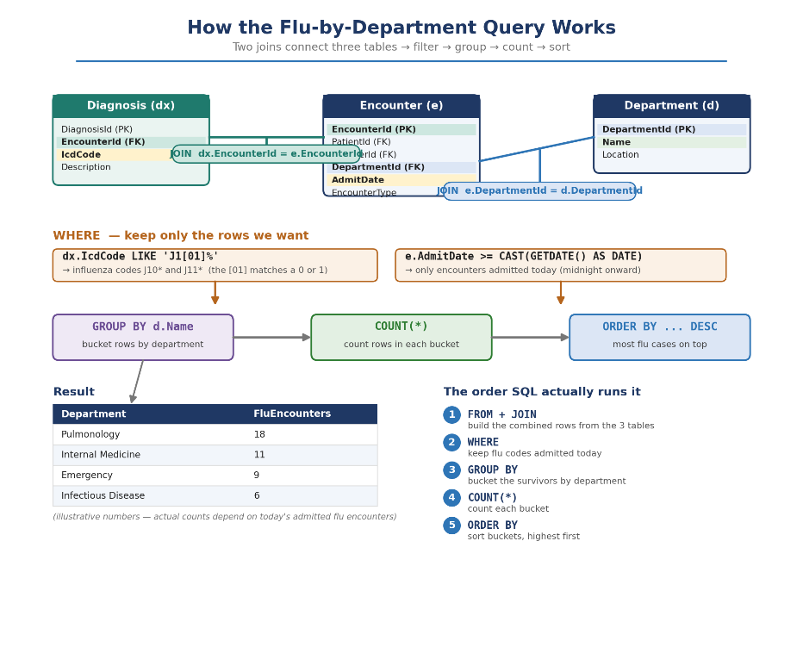
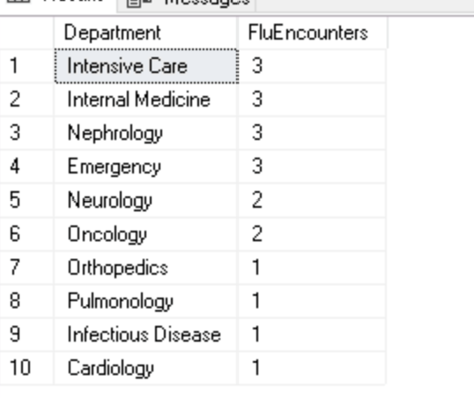
Within seconds leadership can identify where demand is highest and reallocate staff accordingly.
Outcome
By modifying a single business rule:
- Patient intake remained operational during a 300% surge.
- Physicians could focus on treatment instead of registration delays.
- Leadership gained live visibility into outbreak impact.
- Staffing decisions became data-driven.

Architectural Trade-Off
This was not a "free" optimization.
Making ProviderId nullable improves intake speed, but introduces data quality risk.

Potential issues:
- Encounters may never receive a provider assignment.
- Clinical accountability can be lost.
- Reporting accuracy may suffer.

To mitigate this, hospitals typically implement:
- End-of-shift reconciliation reports
- Automated alerts for unassigned encounters
- SLA rules requiring assignment within a fixed timeframe

Key lesson: Good database design is not only about normalization. It is about balancing data integrity, operational realities, and business outcomes.

Key Learning Points
- Model parent tables before child tables; foreign keys enforce the clinical reality (a diagnosis cannot exist without an encounter).
- CHECK constraints encode domain rules (gender, encounter type, claim status) at the database level, not just in app code.
- Schema changes under pressure (the flu surge) are real engineering decisions with trade-offs, not emergencies to improvise.

Module 2 - Temporal Tables & HIPAA Auditing
Goal: Learn how SQL Server automatically preserves every change to sensitive healthcare data, enabling HIPAA-compliant auditing and historical investigations.

The Compliance Investigation
Monday, 8:15 AM
CareBridge receives a formal complaint.
A patient claims:
"My insurance information was changed after my surgery, and now my claim has been denied."
The billing team sees one insurance provider.
The patient insists a different provider existed when treatment occurred.
Compliance Officer Ethan Brooks asks a simple question:
"What exactly did the patient's record look like on the day of treatment?"
- Nobody remembers.
- The application only shows the current value.
- The helpdesk has no screenshots.
- The business cannot rely on memory.
For HIPAA compliance, the database must become the source of truth.

Why This Matters
Consider this record:
Patient: Sarah Johnson
City: Hyderabad
Insurance: BlueCross
A month later:
Patient: Sarah Johnson
City: Bengaluru
Insurance: StarHealth
Without auditing, the old information is gone forever.
Compliance cannot answer:
- Who changed it?
- When was it changed?
- What was the previous value?
- What did the record look like during treatment?
That is a serious risk in healthcare.
Traditional Solution (And Its Problems)
Historically, teams built:
- Audit triggers
- Audit tables
- Application logging
- Custom change tracking

SQL Server Temporal Tables solve this problem natively.
How Temporal Tables Work
Think of a temporal table as a table with memory.
When a row changes:
Current Row
|
| UPDATE
v
Old Version copied automatically
into History Table
The application performs a normal UPDATE.
SQL Server automatically:
- Closes the old version.
- Stores it in a history table.
- Creates a new current version.

No trigger required.
No additional application code required.

CareBridge Audit Targets
Not every table needs temporal history. The highest-value candidates are:
Table | Why Audit Matters
Patient | PHI changes such as city, demographics
Insurance | Coverage disputes and claim investigations
Encounter | Clinical accountability and visit history
These tables contain information that directly impacts treatment, billing, and compliance

Hands-On Lab: Making Patient Temporal
Step 1 - Add System Time Columns
These columns tell SQL Server when a version became valid and when it stopped being valid.
ALTER TABLE Patient
ADD
ValidFrom DATETIME2
GENERATED ALWAYS AS ROW START HIDDEN
CONSTRAINT DF_Patient_From
DEFAULT SYSUTCDATETIME(),

ValidTo DATETIME2
GENERATED ALWAYS AS ROW END HIDDEN
CONSTRAINT DF_Patient_To
DEFAULT '9999-12-31 23:59:59.9999999',

PERIOD FOR SYSTEM_TIME (ValidFrom, ValidTo);

Step 2 - Enable Versioning
ALTER TABLE Patient
SET (
SYSTEM_VERSIONING = ON
(
HISTORY_TABLE = dbo.Patient_History
)
);

Let's Create an Audit Event
Suppose Patient 1 moves cities.
Current record:
PatientId: 1
City: Chennai

Update the row:
UPDATE Patient
SET City = 'Bengaluru'
WHERE PatientId = 1;

Looks harmless.
But behind the scenes SQL Server does something important.

Investigation #1: What Changed?
To see all versions:

SELECT
PatientId,
City,
ValidFrom,
ValidTo
FROM Patient
FOR SYSTEM_TIME ALL
WHERE PatientId = 1
ORDER BY ValidFrom;
Key Learning Points
- System-versioned temporal tables give you a complete, automatic audit trail - the cleanest way to meet HIPAA change-tracking.
- Query the present normally; use FOR SYSTEM_TIME AS OF for point-in-time and FOR SYSTEM_TIME ALL for full history.
- Period columns can be HIDDEN so they do not clutter SELECT *, while still recording every change.
- This replaces fragile hand-written audit triggers - less code, fewer bugs, stronger compliance.

Module 3 - Advanced Queries for Clinical Analytics
The Flu Surge module worked because there was tension. The HIPAA module worked because there was an investigation. For Advanced Queries, The data exists. The challenge is finding the story hidden inside it.
A hospital executive never asks:
"Can you write a CTE?"
They ask: "Why are patients coming back after discharge?"
or
"Why is one department costing us millions?"
That is where CTEs and Window Functions become powerful.
Goal: Learn how hospitals transform raw encounter data into operational decisions using CTEs, Window Functions, and analytical SQL.

Opening Story: The Monday Morning Leadership Meeting
It is Monday morning at CareBridge Hospital. The executive team gathers to review the previous quarter.
The CEO asks: "Are patients getting better after discharge?"
The CFO asks: "Which departments are costing us the most money?"
The Chief Medical Officer asks: "Which patients are repeatedly returning to the hospital?"
The Director of Nursing asks: "Which providers are carrying the largest workload?"
The data exists.
Thousands of encounters. Hundreds of diagnoses. Claims. Admissions. Discharges.
The challenge is not collecting data. The challenge is turning data into answers.

Why We Need CTEs
Most healthcare analytics questions are not solved in one step.
Example:
Find patients who were discharged
then admitted again within 30 days
then identify the department
then identify the provider
then rank them
Trying to do this in one giant query creates confusion. A CTE allows us to build logic in stages.
Think of it as writing a clinical investigation report:
Step 1: Find admissions
Step 2: Compare visits
Step 3: Detect readmissions
Step 4: Produce report
Each step has a name. Each step becomes understandable.

Clinical Investigation #1
Who Came Back Within 30 Days?
Hospitals track 30-day readmissions because they often indicate:
- Poor discharge planning
- Incomplete recovery
- Medication issues
- Follow-up failures
In many healthcare systems, excessive readmissions can result in financial penalties.

Step 1: Arrange Patient Encounters In Order
-- LAG() allows us to look at the previous encounter
-- for the same patient without writing a self-join

WITH OrderedEncounters AS (

SELECT

PatientId,

EncounterId,

AdmitDate,

DischargeDate,

-- Previous discharge for this patient

LAG(DischargeDate)
OVER (
PARTITION BY PatientId
ORDER BY AdmitDate
) AS PreviousDischarge

FROM Encounter

WHERE EncounterType = 'Inpatient'

)

PARTITION BY PatientId tells SQL Server to analyse each patient's encounter history separately. Within each patient's history, ORDER BY AdmitDate arranges encounters in the order they occurred, creating a timeline of care. LAG() then looks at the previous encounter in that timeline, allowing us to compare the current admission with the patient's prior discharge without writing a complex self-join

Step 2: Identify Readmissions
WITH OrderedEncounters AS (

SELECT

PatientId,
EncounterId,
AdmitDate,
DischargeDate,

LAG(DischargeDate)
OVER (
PARTITION BY PatientId
ORDER BY AdmitDate
) AS PreviousDischarge

FROM Encounter

WHERE EncounterType = 'Inpatient'
)

SELECT

PatientId,
EncounterId,
AdmitDate,
PreviousDischarge,

-- Number of days between visits

DATEDIFF(
DAY,
PreviousDischarge,
AdmitDate
) AS DaysBetweenVisits

FROM OrderedEncounters

WHERE PreviousDischarge IS NOT NULL

AND DATEDIFF(
DAY,
PreviousDischarge,
AdmitDate
) <= 30;

The CTE has already calculated the previous discharge date for every inpatient encounter and stored it as PreviousDischarge.
The main query now uses that information to identify potential readmissions. DATEDIFF(DAY, PreviousDischarge, AdmitDate) calculates the number of days between the patient's previous discharge and their current admission.
Encounters where PreviousDischarge is NULL are excluded because there is no earlier visit to compare against.
Finally, the query keeps only those encounters where the gap between discharge and readmission is 30 days or less, which is the standard healthcare definition of a 30-day readmission.
The result is a focused list of patients who returned to the hospital shortly after being discharged, allowing clinicians and leadership to investigate whether the readmissions were avoidable.

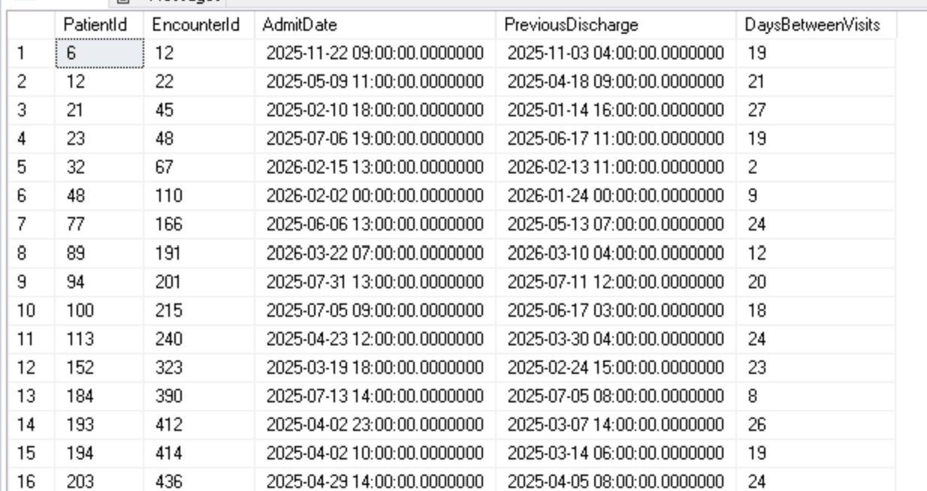

Clinical Investigation #2
Which Department Keeps Patients Longest?
A patient's stay length affects:
- Bed availability
- Staffing
- Cost
- Capacity planning
Leadership wants:
Show each encounter and compare it to the department average.

SELECT

e.EncounterId,

d.Name AS Department,

-- Length of stay for this encounter

DATEDIFF(
DAY,
e.AdmitDate,
e.DischargeDate
) AS LengthOfStay,

-- Average LOS for all encounters
-- in the same department

AVG(
DATEDIFF(
DAY,
e.AdmitDate,
e.DischargeDate
)
)
OVER (
PARTITION BY e.DepartmentId
) AS DepartmentAverageLOS

FROM Encounter e

JOIN Department d
ON d.DepartmentId = e.DepartmentId

WHERE e.DischargeDate IS NOT NULL;

This query measures how long each patient stayed in the hospital and compares that stay against the average length of stay for the department that handled the encounter.
DATEDIFF(DAY, e.AdmitDate, e.DischargeDate) calculates the number of days between admission and discharge, producing the LengthOfStay for each encounter.
The AVG(...) OVER (PARTITION BY e.DepartmentId) window function then calculates the average length of stay across all encounters within the same department, while still keeping each individual encounter visible.
This allows analysts to immediately see whether a particular patient's stay was shorter or longer than the department norm. Hospital leadership often uses this type of analysis to identify departments with unusually long stays, investigate operational bottlenecks, evaluate bed utilization, and improve discharge planning without losing the detail of individual patient encounters.

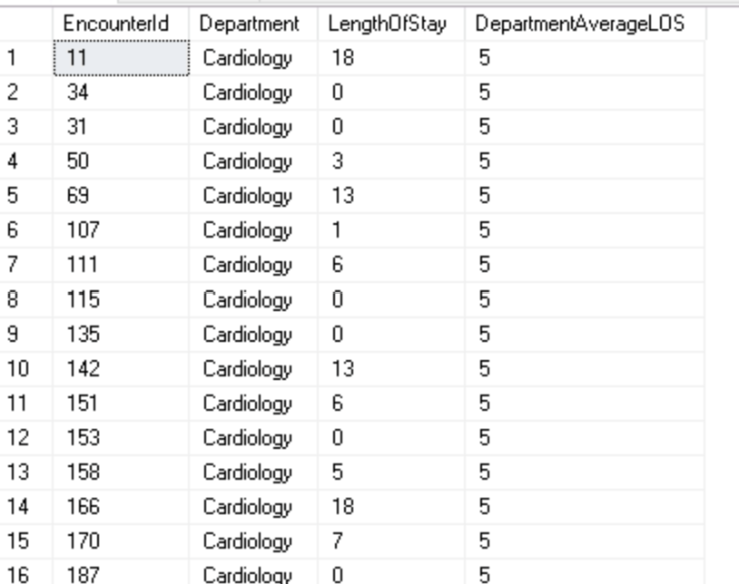

Clinical Investigation #3
Which Providers Carry The Heaviest Workload?
Hospital leadership suspects burnout.
They need provider volume rankings.

SELECT

p.FullName,

COUNT(e.EncounterId) AS EncounterCount,

RANK()
OVER (
ORDER BY COUNT(e.EncounterId) DESC
) AS VolumeRank

FROM Provider p

LEFT JOIN Encounter e
ON e.ProviderId = p.ProviderId

GROUP BY
p.ProviderId,
p.FullName;

This query measures provider workload by counting how many encounters are associated with each provider and then ranking providers from highest to lowest volume.
The LEFT JOIN ensures that all providers appear in the report, even if they currently have no encounters assigned.
COUNT(e.EncounterId) calculates the total number of encounters handled by each provider, and the GROUP BY aggregates the data at the provider level.
The RANK() window function then assigns a ranking based on encounter volume, with the provider handling the most encounters receiving rank 1.
This type of analysis helps hospital leadership understand workload distribution, identify providers managing unusually high patient volumes, detect potential burnout risks, and support staffing and resource planning decisions. Rather than simply listing encounter counts, the ranking makes it easy to see how providers compare against their peers across the organization.
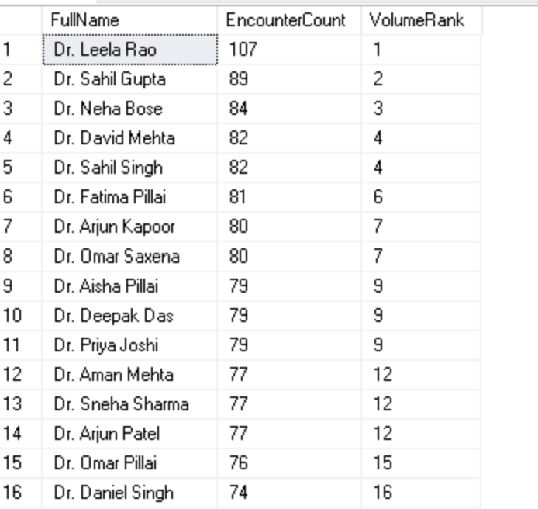

Clinical Investigation #4
Which Patients Are Becoming Frequent Visitors?
One admission may be normal.
Repeated admissions are a signal.
These patients often need:
- Care coordination
- Follow-up programs
- Chronic disease management

WITH AdmissionCounts AS (

SELECT

PatientId,

COUNT(*) AS TotalAdmissions

FROM Encounter

WHERE EncounterType = 'Inpatient'

GROUP BY PatientId

)

SELECT

pt.MRN,

pt.FullName,

ac.TotalAdmissions

FROM AdmissionCounts ac

JOIN Patient pt
ON pt.PatientId = ac.PatientId

WHERE ac.TotalAdmissions >= 3

ORDER BY ac.TotalAdmissions DESC;

This query identifies patients with frequent inpatient admissions, which can be an indicator of chronic health conditions, complications, or gaps in ongoing care.

The CTE first counts the total number of inpatient admissions for each patient, and the main query joins those counts back to the Patient table to retrieve the patient's MRN and name.

By filtering for patients with three or more admissions, the report highlights individuals who may require additional clinical attention, care coordination, or follow-up programs to reduce future hospitalizations.

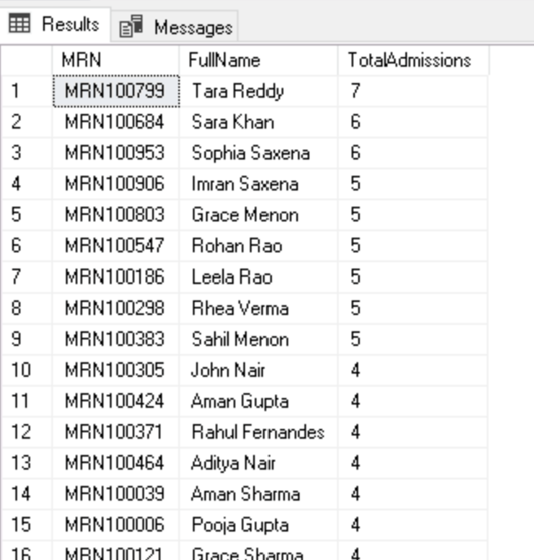

Mini Case Study
The Readmission Crisis

Three months later.
CareBridge receives a warning.

Thirty-day readmissions have increased significantly.
The CEO asks a difficult question:
"Who owns this problem?"

Nobody wants averages.
Nobody wants dashboards.

Leadership wants names.
Which departments?
Which providers?
Which patients?

Step 1 - Find Readmissions

WITH OrderedEncounters AS (

SELECT

PatientId,
EncounterId,
ProviderId,
DepartmentId,
AdmitDate,

LAG(DischargeDate)
OVER (
PARTITION BY PatientId
ORDER BY AdmitDate
) AS PreviousDischarge

FROM Encounter

WHERE EncounterType = 'Inpatient'
),

Readmissions AS (

SELECT *

FROM OrderedEncounters

WHERE PreviousDischarge IS NOT NULL

AND DATEDIFF(
DAY,
PreviousDischarge,
AdmitDate
) <= 30
)

Step 2 - Attribute Accountability

SELECT

d.Name AS Department,

p.FullName AS Provider,

COUNT(*) AS ReadmissionCount

FROM Readmissions r

JOIN Department d
ON d.DepartmentId = r.DepartmentId

JOIN Provider p
ON p.ProviderId = r.ProviderId

GROUP BY

d.Name,
p.FullName

ORDER BY ReadmissionCount DESC;

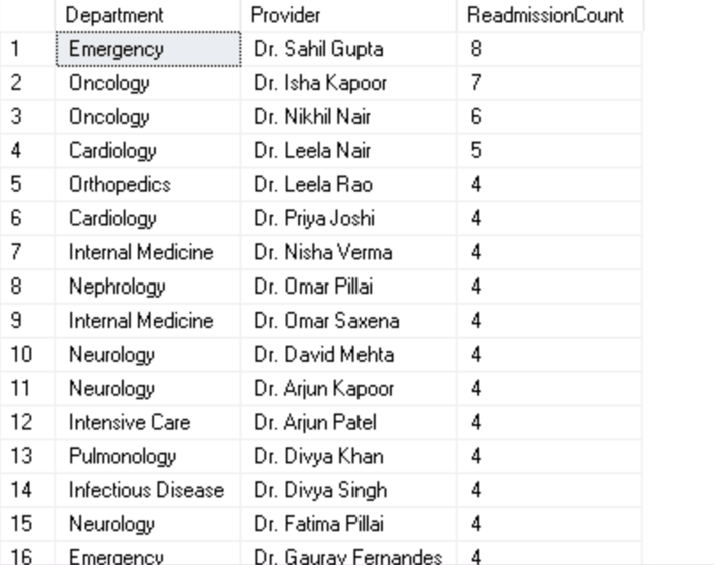

CTEs and Window Functions.

Module 4 - Indexing for Healthcare Scale
Goal: Learn how a few carefully designed indexes can reduce query time from seconds to milliseconds and allow a hospital system to scale from thousands to millions of records.
Opening Story: The Doctor Is Waiting
Monday morning. The Emergency Department is overloaded.
A patient arrives unconscious. The physician asks:
"Show me this patient's last ten encounters."
The nurse clicks Search.
The spinning wheel appears.
5 seconds.
10 seconds.
15 seconds.
The physician is still waiting.

Nobody cares that the database has 40 million encounters.
Nobody cares that the server is busy.
They only care that the answer is not on the screen.
At scale, performance becomes a patient-care issue.

The Real Cost of a Bad Query
Suppose the Encounter table grows to: 40,000,000 rows
A search for one patient might return: 10 rows
Yet SQL Server may read: 40,000,000 rows to find them.
Imagine opening every patient chart in the hospital to find one person's records. That is exactly what a table scan does.

The Golden Rule
Before creating an index, always measure.
Never assume.
-- Show logical reads and CPU usage
SET STATISTICS IO ON;
SET STATISTICS TIME ON;
These are your performance diagnostics.
They tell us:
How much data was read
How much CPU was used
How long the query took
CHECKPOINT;
DBCC DROPCLEANBUFFERS;
DBCC FREEPROCCACHE;

Investigation #1
Why Is Patient Search Slow?
The application searches:
SELECT
PatientId,
FullName,
City
FROM Patient
WHERE City = 'Hyderabad'
AND IsActive = 1;
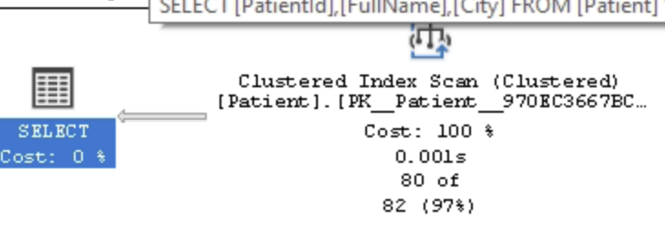

Create An Index That Matches The Search
-- City is filtered
-- IsActive is filtered
-- FullName is returned

CREATE NONCLUSTERED INDEX IX_Patient_City_Active

ON Patient
(
City,
IsActive
)

INCLUDE
(
FullName
);

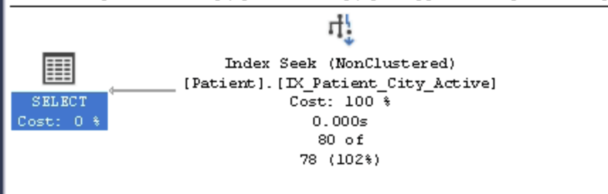

Investigation #2
Recent Encounter Lookup
The ED screen runs:
DECLARE @PatientId INT = 1;

SELECT TOP 10

EncounterId,
AdmitDate,
DischargeDate,
EncounterType

FROM Encounter

WHERE PatientId = @PatientId

ORDER BY AdmitDate DESC;

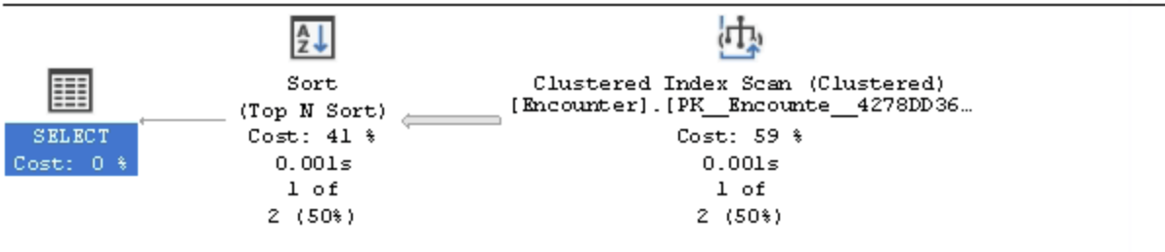
Table 'Encounter'. Scan count 1, logical reads 19, physical reads 1, page server reads 0, read-ahead reads 10, page server read-ahead reads 0, lob logical reads 0, lob physical reads 0, lob page server reads 0, lob read-ahead reads 0, lob page server read-ahead reads 0.

Create The Right Index
-- Match filter first
-- Match sort second

CREATE NONCLUSTERED INDEX IX_Encounter_Patient_Admit

ON Encounter
(
PatientId,
AdmitDate DESC
)

INCLUDE
(
DischargeDate,
EncounterType
);

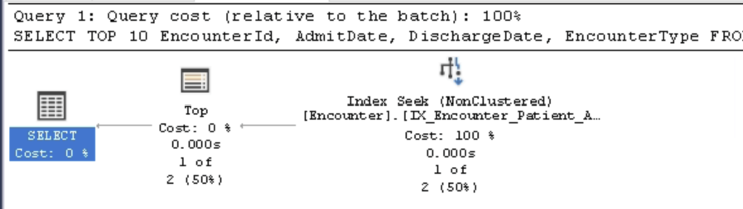

Table 'Encounter'. Scan count 1, logical reads 2, physical reads 0, page server reads 0, read-ahead reads 0, page server read-ahead reads 0, lob logical reads 0, lob physical reads 0, lob page server reads 0, lob read-ahead reads 0, lob page server read-ahead reads 0.

A good index does not make SQL Server work harder. It helps SQL Server avoid work altogether.

Logical Reads
25,000 → 12

CPU
800 ms → 4 ms

Execution Plan
SCAN → SEEK

Module 5 - Stored Procedures & HIPAA-Compliant Views
Goal: Learn how healthcare systems centralize business logic using Stored Procedures and enforce HIPAA's minimum-necessary access principle using Views.
Why This Matters
CareBridge stores clinical, financial, and operational data in the same database.
- Not everyone should see everything.
- A physician needs diagnoses and encounters.
- A billing analyst needs claims and reimbursements.
- An executive needs department-level metrics.
- The database must enforce those boundaries.

Stored Procedures
A Stored Procedure is reusable SQL stored inside the database.
Instead of every application screen writing its own query, everyone calls the same trusted procedure.
Benefits:
- Consistent business logic
- Easier maintenance
- Better security
- Faster application development

Example: Readmission Analytics
Dr. Maya Patel wants a list of patients readmitted within 30 days.
Instead of rewriting the logic across dashboards and reports, we package it once:
EXEC usp_ReadmissionAnalytics
@WithinDays = 30;
The application, reporting team, and analytics team all receive the same answer.

CREATE OR ALTER PROCEDURE usp_ReadmissionAnalytics
@WithinDays INT = 30
AS
BEGIN

SET NOCOUNT ON;

-- Build a patient timeline

WITH OrderedEncounters AS (

SELECT

PatientId,
EncounterId,
AdmitDate,

LAG(DischargeDate)
OVER (
PARTITION BY PatientId
ORDER BY AdmitDate
) AS PreviousDischarge

FROM Encounter

WHERE EncounterType = 'Inpatient'

)

-- Find readmissions

SELECT

PatientId,
EncounterId,
AdmitDate,

DATEDIFF(
DAY,
PreviousDischarge,
AdmitDate
) AS DaysSincePreviousVisit

FROM OrderedEncounters

WHERE PreviousDischarge IS NOT NULL

AND DATEDIFF(
DAY,
PreviousDischarge,
AdmitDate
) <= @WithinDays;

END;

Execute
EXEC usp_ReadmissionAnalytics
@WithinDays = 30;

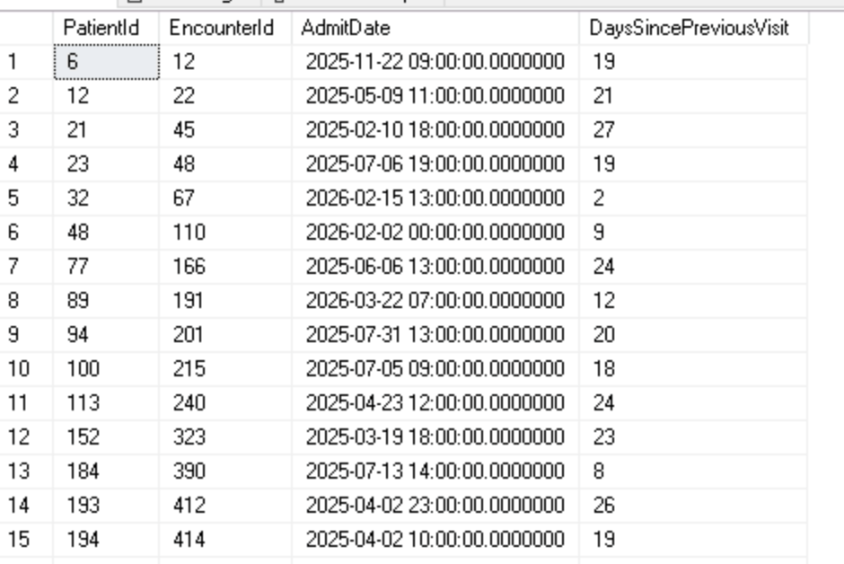

HIPAA & Minimum Necessary Access
HIPAA does not ask: Can the user access the database?
HIPAA asks: Does the user need this information to perform their job?
The answer determines what data they should see.

Clinical View
Business Problem
Physicians need diagnoses and encounter details, but they do not need billing information.
Create View
CREATE OR ALTER VIEW vw_Clinical
AS
SELECT
pt.MRN,
pt.FullName,
e.EncounterId,
e.EncounterType,
dx.IcdCode,
dx.Description
FROM Patient pt
JOIN Encounter e
ON e.PatientId = pt.PatientId
LEFT JOIN Diagnosis dx
ON dx.EncounterId = e.EncounterId;
Test
SELECT *
FROM vw_Clinical;

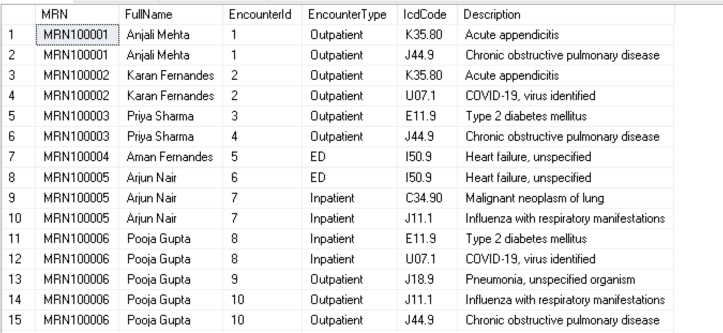

Module 6 - Building a Clinical Operations Console with .NET + SQL Server + Python
Goal: Use the CareBridge healthcare database inside a real .NET application and operational analytics workflow.
1. A C# console application for operational reporting
2. A SQL Server stored procedure backend
3. A Python analytics script for risk analysis

Business Scenario - “The Monday Morning Readmission Review”
Every Monday morning, Dr. Maya Patel reviews patients who returned to the hospital within 30 days.
The hospital wants:
- A .NET application to generate the report
- SQL Server to calculate readmissions
- Python to identify trends and risk patterns
The output will help leadership:
- Identify repeat admissions
- Detect operational failures
- Prioritize follow-up care

Step 1 - Use The Existing Stored Procedure
usp_ReadmissionAnalytics
Now they will consume it from a real application instead of manually running SQL.
Step 2 - Create A .NET Console Application
Inside Visual Studio 2022:
File
→ New Project
→ Console App (.NET)
→ Name: CareBridgeAnalytics
Install SQL Server package:
Tools
→ NuGet Package Manager
→ Install: Microsoft.Data.SqlClient

Step 3 - Connect C# To SQL Server
Program.cs
using Microsoft.Data.SqlClient;
// Connection string to SQL Server
string connectionString =
"Server=localhost;" +
"Database=CareBridgeDB;" +
"Trusted_Connection=True;" +
"TrustServerCertificate=True;";
// Stored procedure we already created in SQL Server
string procedure = "usp_ReadmissionAnalytics";
using SqlConnection conn =
new SqlConnection(connectionString);
using SqlCommand cmd =
new SqlCommand(procedure, conn);
// Tell C# this is a stored procedure
cmd.CommandType =
System.Data.CommandType.StoredProcedure;
// Parameter value
cmd.Parameters.AddWithValue(
"@WithinDays",
30
);
conn.Open();
using SqlDataReader reader =
cmd.ExecuteReader();
Console.WriteLine(
"30-Day Readmission Report"
);
Console.WriteLine(
"--------------------------"
);
// Read each returned row
while (reader.Read())
{
Console.WriteLine(
$"Patient: {reader["PatientId"]} | " +
$"Encounter: {reader["EncounterId"]} | " +
$"Days Since Previous Visit: " +
$"{reader["DaysSincePreviousVisit"]}"
);
}

Why Stored Procedures Matter In Applications
Without procedures: SQL gets duplicated across applications
With procedures: Business logic stays centralized inside SQL Server
The .NET application becomes thinner, safer, and easier to maintain.

Create a View and consume it in .NET Application
CREATE OR ALTER VIEW vw_Analytics_DeId
AS
SELECT
e.EncounterId,
CASE
WHEN DATEDIFF(YEAR, pt.DateOfBirth, GETDATE()) < 18 THEN '0-17'
WHEN DATEDIFF(YEAR, pt.DateOfBirth, GETDATE()) < 65 THEN '18-64'
ELSE '65+'
END AS AgeBand,
pt.Gender,
e.EncounterType,
e.DepartmentId
FROM Patient pt
JOIN Encounter e
ON e.PatientId = pt.PatientId;

.NET Application: Safe Analytics Query
using Microsoft.Data.SqlClient;

string connectionString =
"Server=localhost;" +
"Database=CareBridgeDB;" +
"Trusted_Connection=True;" +
"TrustServerCertificate=True;";

string query =
@"SELECT TOP 10
AgeBand,
Gender,
EncounterType
FROM vw_Analytics_DeId";

using SqlConnection conn =
new SqlConnection(connectionString);

using SqlCommand cmd =
new SqlCommand(query, conn);

conn.Open();

using SqlDataReader reader =
cmd.ExecuteReader();

Console.WriteLine("CareBridge Analytics");
Console.WriteLine("-------------------");

while (reader.Read())
{
Console.WriteLine(
$"{reader["AgeBand"]} | " +
$"{reader["Gender"]} | " +
$"{reader["EncounterType"]}"
);
}

